Week of Prayer for Christian Unity 2020 (25-31 May)
“They showed us unusual kindness”
(cf. Acts 28:2)

Activities for children’s liturgy or to be done at home

1. Look at a map of the area around Malta. Where is it in the world? What countries are close to it? How big is it in comparison to New Zealand?

2. Make a cardboard boat (Google has many ways of doing this) or alternatively using coloured tape, mark out the shape of a boat on the floor.

3. Using a large blue cloth, ask each of the children to hold a section of the fabric and move it up and down to represent the strong wind and waves.

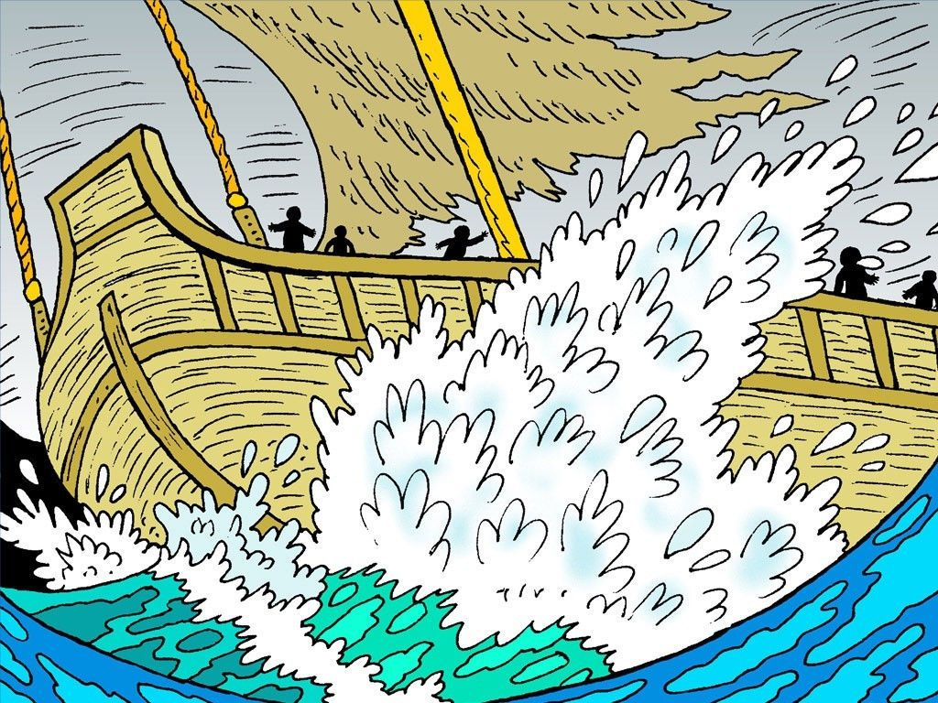
4. This passage from the Acts of the Apostles is very dramatic and lends itself to acting out. Children may be invited to play various non-speaking roles as the passage is read. For example, children could sit in marked out boat and sway back and forth to show that the ship is in a storm. When the reading describes Paul standing up and speaking, one child may stand to represent Paul. There may be a group of children who act out a struggle to show how the guards wanted to harm the prisoners and one child can be the centurion who stops them. There can be children who represent the natives of Malta who show kindness and hospitality. This may help to keep children engaged for what is otherwise a long passage of Scripture.

5. Children could be asked about what hospitality means, and build up some simpler words to explain it. How do they show hospitality at home and at school? Encourage them to name ways our church welcomes people, and makes them feel at home.

6. Children could be in charge of serving at a morning tea following the Mass, or serving people in their home – allowing them to take a leadership role in providing hospitality.

7. Fill a medium container with water. Investigate with children what objects float and which objects sink. Objects may include: a small rock, a feather, an iceblock stick, a pen, keys, a toy boat. Although the feather floats, it is not strong so nothing can stand on it or float on it. The iceblock stick floats but it is hard to hold on to. The boat, however, can have people in it. The church is like a boat that helps us to keep afloat and carries us to safety.

8. Have children make an oar each, and decorate it with symbols of kindness. Ask what it is and what it’s for. What happens to the people in a boat who have no oar? (lose speed and direction; can’t get anywhere.) Brainstorm with the children how prayer, scripture, the church community, parents etc are all like ‘oars’ for us.

http://www.freebibleimages.org/illustrations/paul-shipwrecked/

